**Planning an oral presentation**

Welcome to the fourth and final chapter! We now know

**Presentation strategy**

which elements we should consider when choosing the appropriate format to deliver our results. We focused on written reports, now let's turn our attention to oral presentation. We'll learn to plan and build the presentation slides, to avoid common mistakes and pitfalls, and to deliver the presentation effectively.

**Plan a presentation**

Just as it is a bad idea to dive straight into writing code for a data analysis without first thinking about what you want to do, it is usually a bad idea to dive into writing slides without planning. To help structure the presentation, we should consider its purpose, who the audience is, and the message we want to get across.

1. 1 Schwabish J. Better Presentations. Columbia University Press. 2017.

**Purpose**

Let's go back to our sentiment analysis of product reviews that we summarized in a report in Chapter 3. To define the purpose of the presentation, we consider the type of presentation we are giving. Is it an informative presentation? If so, we might want to inform about the current number of negative and positive ratings and words associated with negative reviews.

**Purpose**

Are we trying to instruct our colleagues or coworkers? Then we might want to explain how the model for sentiment analysis was built. or are we trying to persuade some stakeholders? Our purpose would then be to convince stakeholders that actions need to be taken to revert the high numbers of negative ratings.

**Audience**

After understanding the purpose of our presentation, we should think about who our audience is. Are we presenting to a technical colleague, to a manager or executive team or to the customer?

But we should also think how big our audience is. Are we presenting in a small meeting, for example to 10 members of the financial team? Or is it large meeting or a conference? For example, a meeting with 100 employees from the software development department? Or maybe we are giving a workshop, like a technical training for 30 customer's employees from their respective IT departments?

**Message**

Our audience will have forgotten 90% of the presentation a week after seeing it. If they only remember one thing from your presentation, what do you want it to be? You can then work backwards from that to decide what needs to be included in the presentation to get the audience there. Our opening statement should hook our audience and introduce this one thing you want the audience to walk away with. For example: negative ratings scare customers away from our website.

**Message**

Then, we decide on the central message. It is advisable to just use one sentence. We might convey that delayed shipping is the main cause of negative reviews and immediate actions are needed to revert the situation.

Finally, we need a closing statement that sums up the presentation and strengthens the central message. We might say that there is a decrease in sales. Negative reviews have been increasing. Delayed shipping is causing negative ratings, and actions are needed to revert situation.

**Structure**

Taking all these steps into account, we can think about the structure. Starting with the introduction, we should provide some background information to catch our audience's attention and give them a glimpse of the presentation content.

**Structure**

After that, we can dive into the methods, analysis and model outputs. Who our audience is determines how detailed this part should be: if our audience is non-technical, you might justify skipping this entirely.

Finally, we conclude, referring back to the introduction, adding a call-to-action statement or recommendations for next steps. This structure helps keeping our audience engaged, who is likely more attentive at the beginning and end of our talk.

**Outline**

Now it's time to outline the graphs and visuals we want to use, and plan which sections we need, and their order. We should have around five sections and avoid having too many in general. It can make it hard to maintain our audience's attention. We might have the following sections: The reason for analysis the exploratory analysis, the sentiment analysis itself, the conclusions, and the follow-up actions.

**Keep time in mind!**

Last but not least, how long we have to deliver our presentation impacts how we plan it. We will talk about timing again later in this chapter.

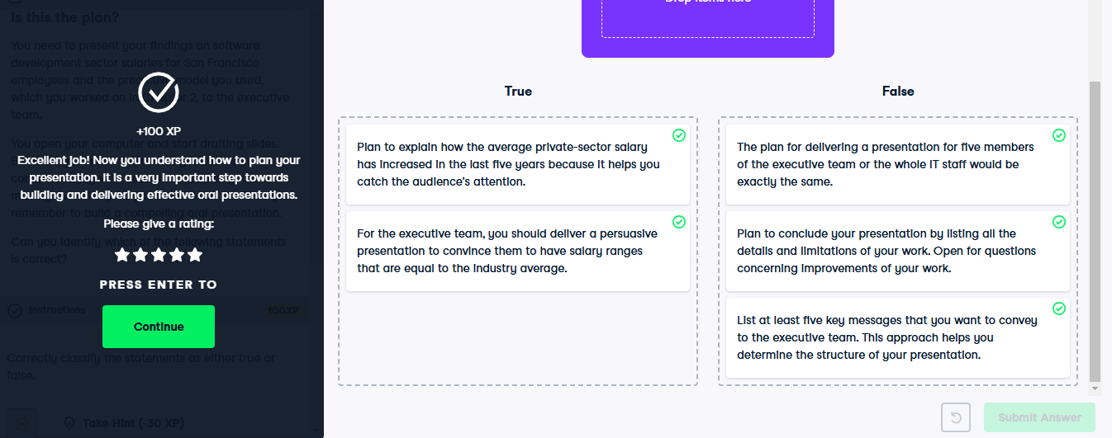

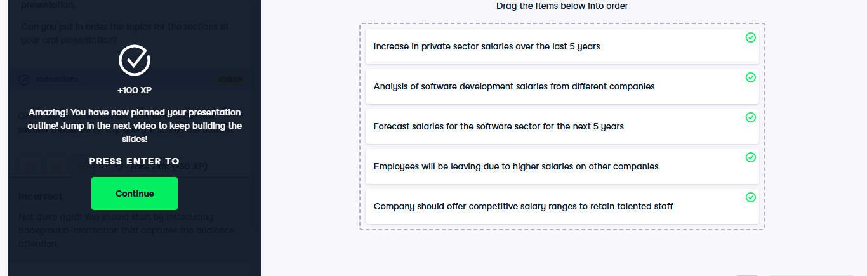

**Building presentation slides**

In the previous video, we've seen how planning is paramount before actually building slides.

**2. From planning to building**

00:06 - 00:27

Now, we should design the slides. There are some suggestions we can follow. Our slides should support the story we are conveying. When building the slides, we should keep in mind our audience attention capacities. It's better to have many slides with little content on each, making for a more dynamic presentation, rather than few slides with lots of content.

**3. From planning to building**

00:27 - 00:40

There's a good reason for counting slides: the idea is to prevent presenters from going over time. But we shouldn't worry about counting slides or how much time we spend on each. Instead,

**4. From planning to building**

00:40 - 01:00

we should have one message per slide. It will keep things short and fluid. Our audience can only absorb a certain amount of information at once. Trying to cover too much information simultaneously will increase the cognitive load, cloud our message, and cause our audience to miss some of the key points.

1. 1 https://www.slidecow.com/blog/how-many-slides

**5. Color**

01:00 - 01:28

Formatting can emphasize, or on the contrary cloud, the message we want to convey. One formatting technique is color. Remember, everything you present should convey meaning, and everything else should be cut. So as far as colors are concerned, we use the least amount of colors needed to convey our message. Also, we should maintain a good contrast between your text and background, to help readability.

**6. Color**

01:28 - 01:43

We also need to be attentive to potentially impaired auditors. People who have color-vision deficiency can't distinguish between two different colors, so those people will struggle to understand the text or graph on the slides if you use green and red together.

**7. Fonts**

01:43 - 02:30

Fonts also impact readability. The research is inconclusive on which typeface is easier to read between serif and sans-serif. The rule of thumb would be sans serif is appropriate for text that will be read on a screen, and serif is appropriate for text that will be printed. The font choice is also contextual: Comic Sans Ms gets a bad rep, but it's a great font if presenting to kids. Not so much in a business setting. In the end, the slide content is there to support what we're saying. And usually, texts are hard to read not because of the font choice, but because they are long texts in a small size. Let's keep our texts short and big instead.

**8. Fonts**

02:30 - 02:46

We can also use several fonts, change the spacing of letters and lines, as well as use bold, italic and various font sizes. We should use as little of these to get our message across without distracting from it.

**9. Text slide**

02:46 - 02:53

Including too much text can have a negative impact. The audience tends to read the slide instead of listening.

1. 1 Schwabish, J. Better Presentations . Columbia University Press. 2017.

**10. Text slide**

02:53 - 03:10

Instead we should write the main points supporting our message. The slides are just a support. They are not built to be consumed without a presenter: if they need to be, then a recording can do the trick - but we shouldn't dual purpose our slides into written reports.

**11. Text slide**

03:10 - 03:27

Including a slide headline helps persuade the audience to pay attention at that particular moment of the presentation. The headline should highlight the main point of the slide, be concise and specific, and be visible thanks to a bigger font.

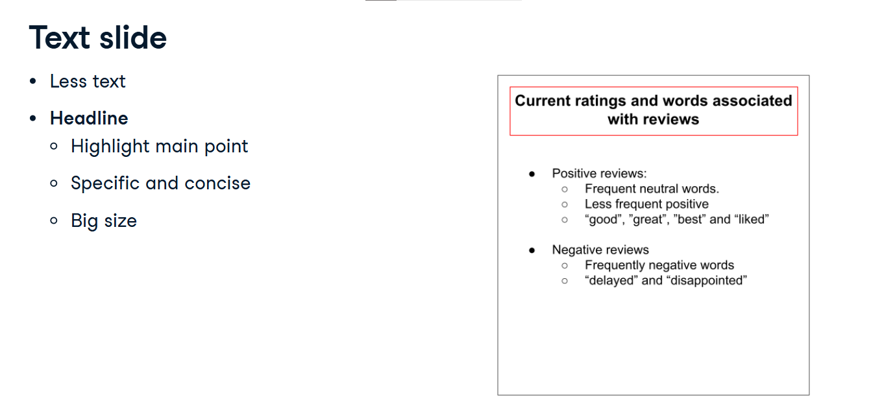

**12. Text slide**

03:27 - 03:39

Layering is a powerful tool which breaks a complex slide into smaller points. The idea is to have a cleaner, better structured slide making it easier to focus on each part

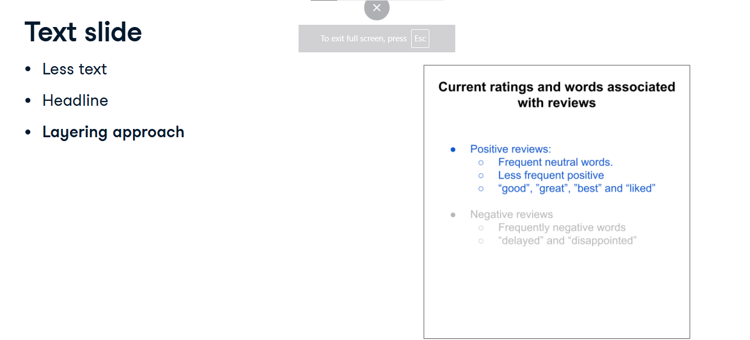individually.

**13. Text slide**

03:39 - 03:42

Each point is presented and explained on its own,

**14. Text slide**

03:42 - 03:49

before being displayed together to wrap up the message. This approach helps focus our audience's attention.

**15. Visualization slide**

03:49 - 03:59

When we find ourselves using too much text, we should think about replacing it with a graph. People usually understand visual information much better.

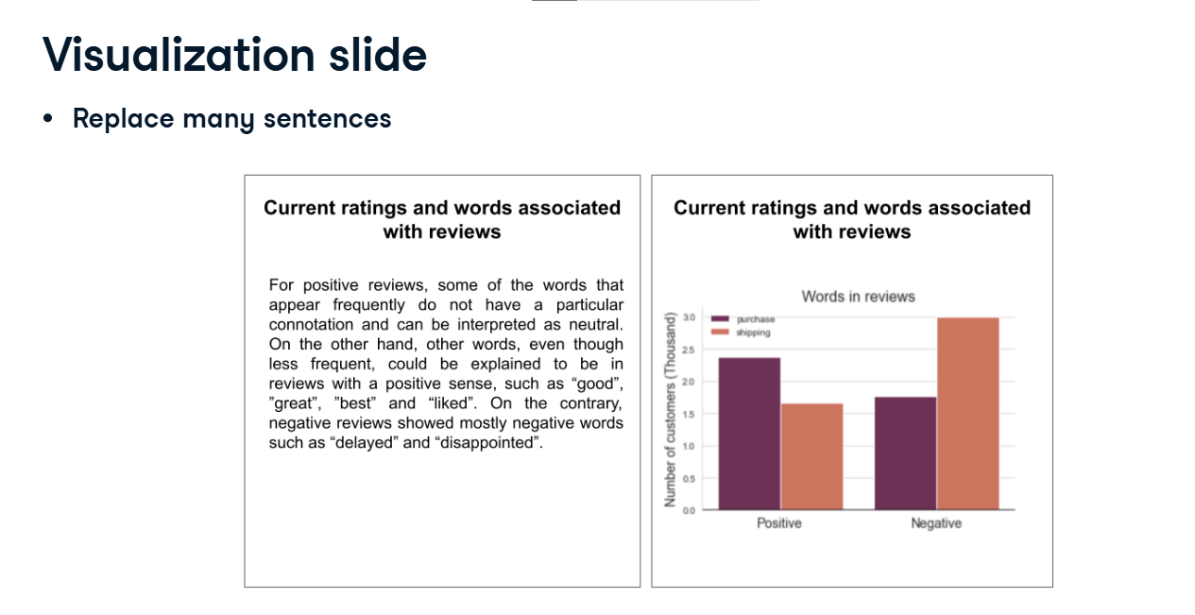

**16. Visualization slide**

03:59 - 04:20

Layering and highlighting also work pretty well: we can display each graph one by one, and put them together to summarize the idea. Highlighting the graph or part of the graph can also help us direct our audience to what we are explaining. It also works for text, to highlight an idea or a metric.

**17. Visualization slide**

04:20 - 04:26

If needed, headlines should also be used following the same guidelines that we saw for text slides.

**18. Visualization slide**

04:26 - 04:37

Finally, we should use only one or two full-size graphs per slide, preventing us from conveying more than one message per slide, and prevent us from overcrowding slides.

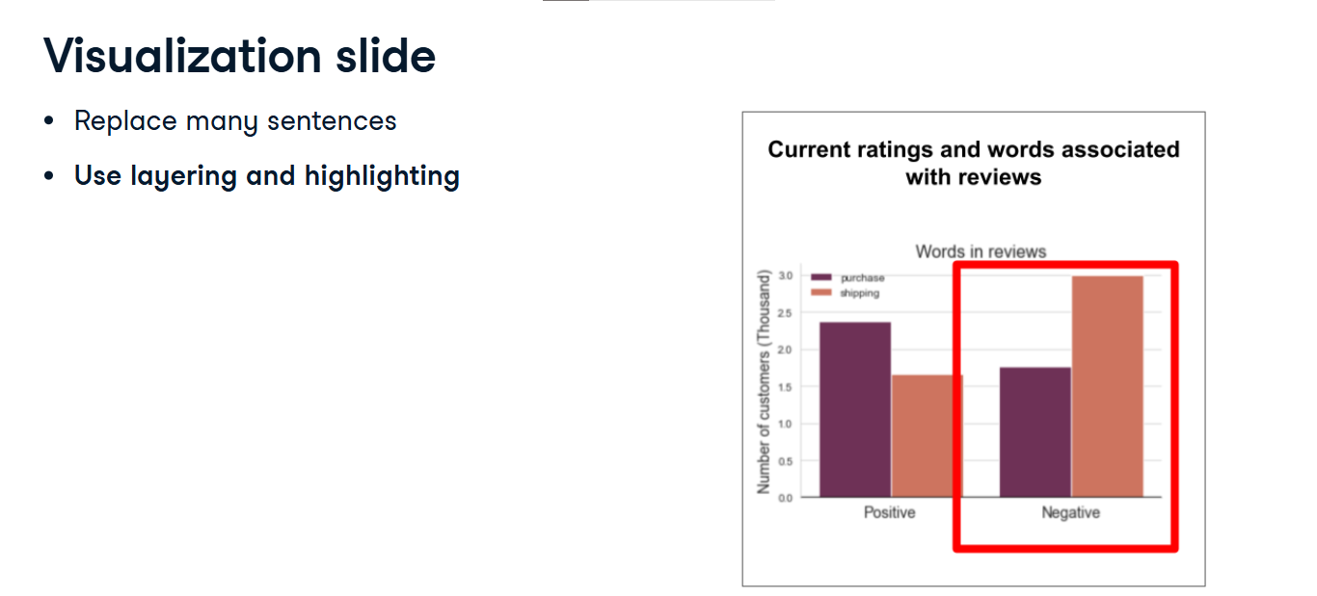

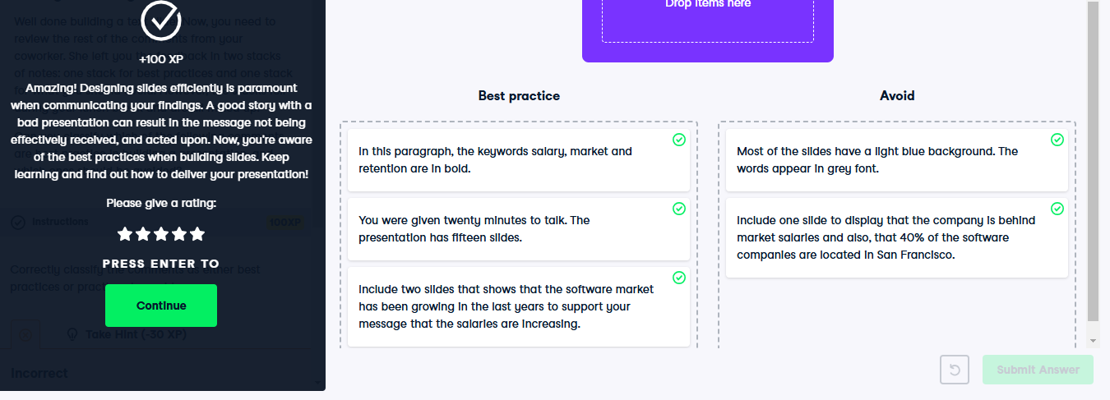

**Delivering the presentation**

Good job building engaging and effective presentations!

**2. Recap**

00:05 - 00:14

We now understand that we need to plan the presentation before building slides. And those slides should be built to support the story we want to convey.

**3. Practice**

00:14 - 00:44

Now, it's time to discuss delivery. One of the most important things is to practice. Writing a script is helpful. The idea isn't to memorize it by heart, but to use it as a guide to efficiently articulate the reasonings and insights. The more we practice, the more familiar we will become with our content. Moreover, we should anticipate follow-up questions, and think about appropriate answers to them.

**4. Practice**

00:44 - 01:19

Practicing means rehearsing as close to the presentation context as possible, which involves standing up, using the actual slides, and speaking out loud. As we practice we can identify distracting patterns or filler words such as "um", "so" or "like". Additionally, sometimes things don't sound as good spoken as they looked when written. It is also an opportunity to find linking statements, or sentences to transition from one slide to the other. Last but not least, we should also practice how to answer to follow-up questions we have anticipated.

**5. Deliver the presentation**

01:19 - 01:42

Practicing our presentation many times is an effective way to be familiar with our content. But there are a couple of things we should consider while delivering the presentation. The first thing is being aware of our emotions. The audience will pick up on them. If we are self-assured, they are going to be confident in our content. If we look nervous or confused, they might be unconvinced.

**6. Deliver the presentation**

01:42 - 02:23

How long the audience's attention span lasts varies depending on the setting, but researchers agree it's between 5 and 20 minutes. So we should go the extra mile to keep the audience engaged. We can use eye contact, interactivity, questions - the idea is simply to talk to them, not at them. We're building a relationship with our audience: let's show empathy, act as a guide. We shouldn't use sentences like "as you know", or "obviously". We might damage our connection with the audience if they feel like they don't understand something, or if they are uncomfortable asking questions.

**7. Deliver the presentation**

02:23 - 02:34

We should make sure our presentation doesn't last longer than the allocated time. The audience will get impatient if we take longer than expected, and their attention will drop dramatically.

**8. Deliver the presentation**

02:34 - 02:48

The audience will understand us better if we make pauses. If we want to convey urgency, it's OK to talk a little faster. But after conveying the idea, we should breathe and give the audience time to think.

**9. Deliver the presentation**

02:48 - 03:03

Finally, we should always open up for questions either during or at the end of the presentation. It will show that we are open to feedbacks, interested in what our audience has to say, and willing to help them understand our message.

**10. An effective oral presentation**

03:03 - 03:17

So in general, to give a good oral presentation we should always remember: to talk to the audience (and not at it), that less is more, that the take-home message should be consistent and persistent, to practice, and to prepare for follow-up questions.

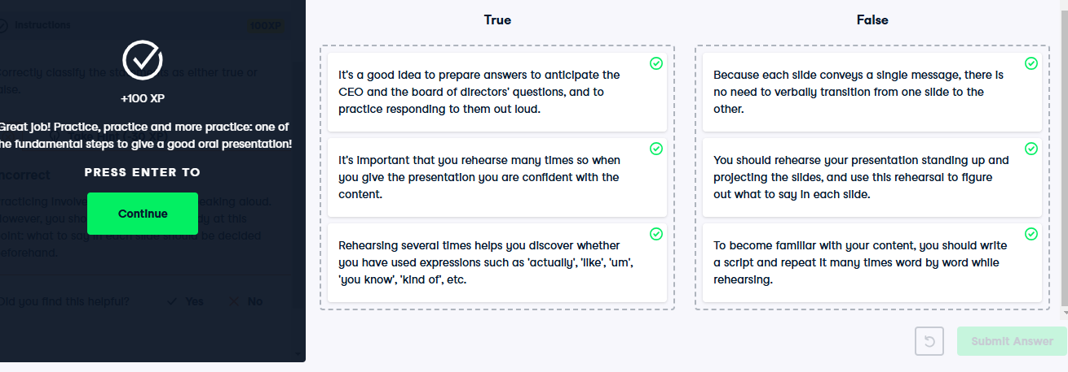

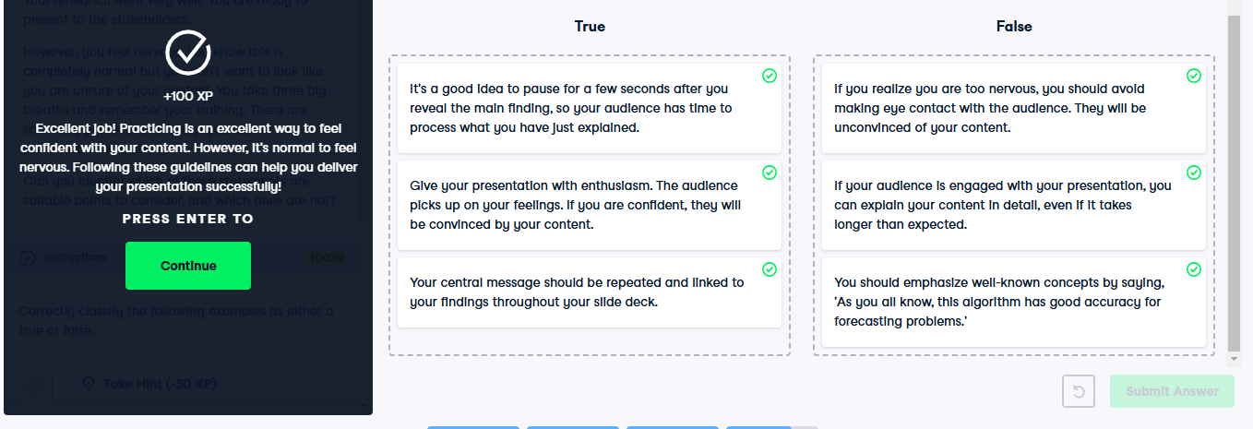

**Avoiding common errors**

We have just learned a set of best practices to deliver impactful presentations. In this video, we'll talk about common mistakes we should avoid.

**2. Recap**

00:10 - 00:30

But first, let's recap. In order to deliver a compelling presentation, we first need to plan what we are going to present (following some guidelines). An important step is to prepare and practice our speech: the more we practice, the better we become. Lastly, we can deliver the presentation, provided we avoid some common mistakes.

**3. Length**

00:30 - 00:50

A lot of presentations are ineffective because they are too long. The audience has an attention span that we should take into account, and if we go beyond 20 minutes, we are at risk of losing them. Moreover, it is important to keep some time for questions the audience may have. People that are interested in our project surely will have some.

**4. Purpose**

00:50 - 01:09

A common mistake is to forget to state the purpose of the presentation in the introduction. This simple mistake could ruin the rest of the presentation, preventing the audience from understanding the importance of our findings and leaving them in the dark throughout the presentation, diminishing the impact of our story.

**5. Guide audience**

01:09 - 01:31

As speakers, we should guide the audience, deliver a sequence of information that supports our story, and keep our audience's attention. To that aim, we should not wait until the end of the presentation to show all our findings together. Instead, we should include them throughout the presentation, providing a backbone to the message.

**6. Audience involvement**

01:31 - 01:41

Another common mistake is to just give the presentation as a monologue, without engaging and involving the audience. Remember we're presenting to them, not at them.

**7. Audience involvement**

01:41 - 01:47

First, we should introduce ourselves using a strong statement, saying who we are and why we are presenting.

**8. Audience involvement**

01:47 - 01:57

Because our audience is not aware of our thought process, we should always state our key assumptions. This gesture shows empathy.

**9. Audience involvement**

01:57 - 02:07

Another way to connect with the audience is to ask questions in the middle of the presentation. Ideally, we should know the answer and it can serve as a hook for our next slide.

**10. Audience involvement**

02:07 - 02:17

Lastly, we can keep our audience engaged by always relating what we are showing to the main idea. In that way, they can keep track of our story easily.

**11. Body language**

02:17 - 02:24

If what matters is the message, the speaker is at the center of the presentation.

**12. Body language**

02:24 - 02:35

We can use that to our advantage and create emphasis using natural gestures and movements - for example, moving our hands or pointing at the slide, smiling or making a facial expression.

**13. Body language**

02:35 - 02:38

Good body language conveys confidence and strengthens attention,

**14. Body language**

02:38 - 02:48

so our audience will be more focused on our message. This is especially true for live presentations, a little less for online presentations.

**15. Voice tonality**

02:48 - 02:56

Our voice is also a tool we should use as speakers. We should use different voice tonalities to emphasize our message.

**16. Voice tonality**

02:56 - 03:15

For example, varying the speed of our voice make our talk more interesting. We can speak fast to denote a sense of urgency, excitement or emotion, or slow to highlight the importance of a finding, introduce new ideas, or hammer fundamental ones.

**17. Voice tonality**

03:15 - 03:29

We should also speak loud enough so that the audience can hear us if we are giving an in-person presentation. In case of online presentations, we should check that our microphone is properly set so that our voice is clear.

**18. Voice tonality**

03:29 - 03:44

Intonation also matters. It's difficult to give blanket advice, as it depends on the language, but basically we need to sound engaged. If we don't appear interested by what we present, we can't expect our audience to be.

